Lab No.: Lab-1
Lab Aim and Objective: To study and apply Data Preprocessing techniques on given dataset. Prepare a titanic dataset for training with machine learning algorithm by applying suitable data preprocessing techniques.
Dataset or resources used: Titanic dataset (titanic.csv), Python, Jupyter Notebook, Pandas, Numpy, Matplotlib, Seaborn, Scikit-Learn.
Date of Performance: 09 July 2026

1. Theory based on the lab objectives
Data preprocessing is a crucial step in any machine learning pipeline. Real-world data is often incomplete, inconsistent, and lacking in certain behaviors or trends. Data preprocessing involves transforming raw data into an understandable format. This lab focuses on several key techniques:
1. Handling Missing Data: Missing values can skew models and lead to incorrect conclusions. We can handle them by removing the affected rows/columns or imputing them using statistical measures like median or mean.
2. Categorical Data Encoding: Machine learning models require numerical input. Categorical variables (like 'Sex' or 'Embarked') must be converted into numerical formats using techniques such as label encoding or one-hot encoding.
3. Feature Scaling: Features often vary in magnitudes, units, and range. Algorithms that compute distance (like KNN or SVM) or use gradient descent are highly sensitive to these variations. Scaling features (e.g., using StandardScaler) normalizes the data within a particular range, speeding up calculations and improving accuracy.
4. Exploratory Data Analysis (EDA): Visualizing data helps in understanding the underlying distribution, detecting outliers, and identifying correlations between features.

2. Written code uploaded to GitHub
The written code for this practical is uploaded and available at the following GitHub URL:
https://github.com/NodeNexus/MachineLearningProjects

3. Procedures and materials used
Materials Used:
- Hardware: Standard PC/Laptop
- Software: Windows OS, Python 3, Jupyter Notebook
- Libraries: Pandas for data manipulation, Numpy for numerical operations, Matplotlib and Seaborn for data visualization, Scikit-Learn for preprocessing.
Procedures:
1. Imported necessary libraries (pandas, numpy, matplotlib, seaborn).
2. Loaded the 'titanic.csv' dataset into a pandas DataFrame.
3. Performed preliminary exploratory data analysis using head(), tail(), info(), and describe() functions.
4. Checked for missing values across the dataset and handled them (e.g., imputing 'Age' and 'Embarked' with median values).
5. Dropped irrelevant features such as 'PassengerId' and 'Cabin' that do not contribute significantly to the predictive model.
6. Converted categorical variables ('Sex' and 'Embarked') into numeric values for model compatibility.
7. Generated various visualizations (boxplots, histograms, scatter plots, count plots, and heatmaps) to identify trends, distributions, and outliers.
8. Separated the features (X) and the target variable (y) 'Survived'.
9. Applied standard scaling to continuous variables like 'Age' and 'Fare' to normalize their distributions.
10. Split the dataset into training and testing sets using train_test_split (80% training, 20% testing).

4. Output screenshots with proper descriptions
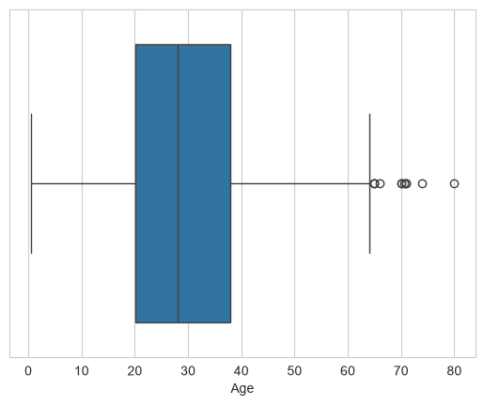
This boxplot displays the distribution of the 'Age' feature among the passengers. The median age is centrally located within the interquartile range box. The whiskers indicate the variability outside the upper and lower quartiles, and the isolated points on the right side represent outliers, indicating the presence of older passengers on board. This visualization helps in identifying age distribution anomalies.

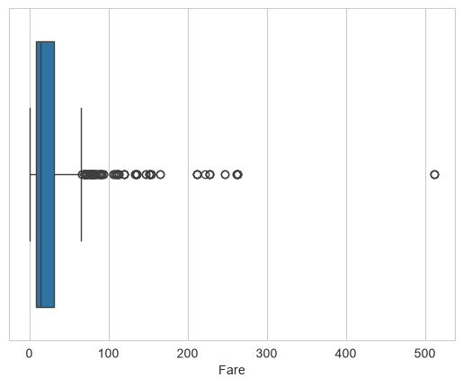
This boxplot illustrates the distribution of ticket 'Fare' paid by the passengers. It shows a highly skewed distribution with a concentration of lower fare values. The numerous dots extending to the far right represent extreme outliers, indicating that a few passengers paid significantly higher fares than the vast majority. This right-skewness suggests the need for scaling or transformation.

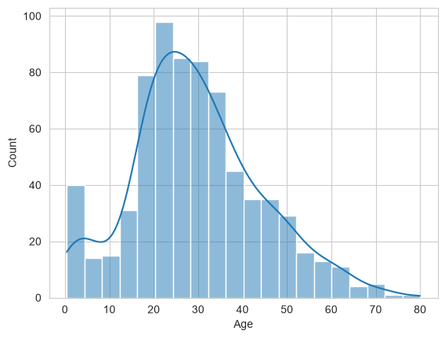
This histogram with a Kernel Density Estimate (KDE) curve shows the age distribution of passengers on the Titanic. The distribution is somewhat normal but slightly right-skewed, with the highest concentration of passengers falling in the 20 to 30 years age range. There is also a noticeable peak in the infant/toddler range, reflecting families traveling with young children.

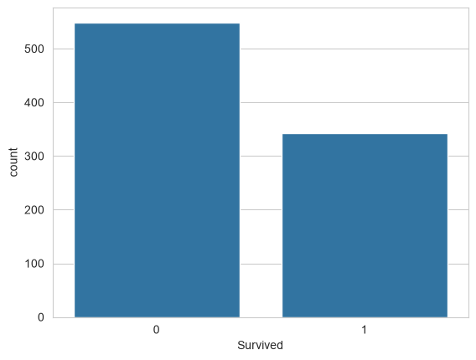
This count plot compares the number of passengers who survived (1) versus those who did not (0). It clearly demonstrates that the number of casualties significantly exceeded the number of survivors. This baseline distribution highlights the class imbalance in the target variable, which is an important consideration for evaluating the performance of machine learning classification models.

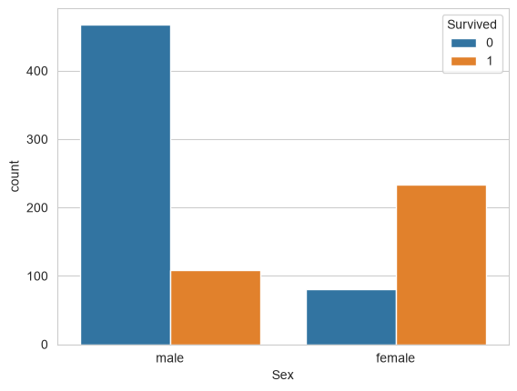
This grouped count plot visualizes the survival rates categorized by passenger gender. It starkly reveals that a much larger proportion of female passengers survived compared to male passengers, while a massive number of male passengers did not survive. This aligns with the historical 'women and children first' protocol and shows that 'Sex' is a very strong predictor of survival.

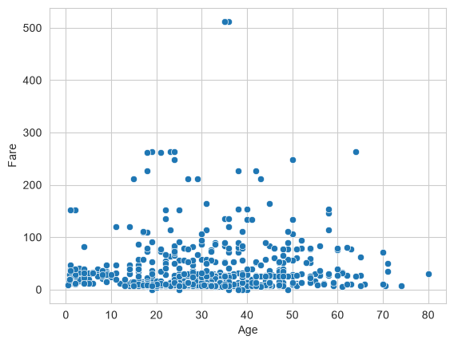
This scatter plot maps the relationship between 'Age' (x-axis) and 'Fare' (y-axis) for the passengers. It shows that fare prices are generally concentrated at the lower end regardless of age, but the highest fares were primarily paid by middle-aged individuals (around 30-60 years old). The plot also clearly highlights the extreme fare outliers present in the dataset.

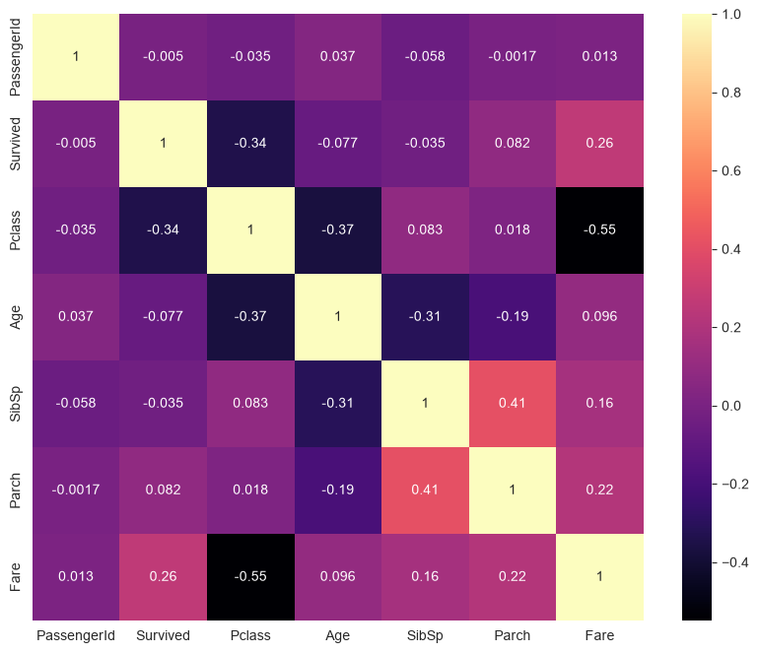
This heatmap visualizes the correlation matrix for all numeric features in the dataset. The color intensity and annotated values indicate the strength and direction of linear relationships between variables. For instance, 'Fare' shows a moderate positive correlation with 'Survived', while 'Pclass' shows a negative correlation, indicating higher class passengers (lower Pclass value) were more likely to survive and paid higher fares.

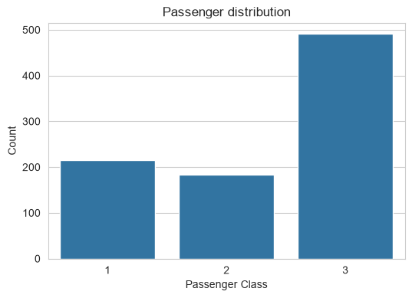
This count plot displays the distribution of passengers across the three ticket classes (1st, 2nd, and 3rd). It reveals that the majority of the passengers were traveling in the 3rd class, which was the cheapest option. 1st class has the second highest number of passengers, followed by 2nd class. This socioeconomic distribution is critical context for understanding survival rates.

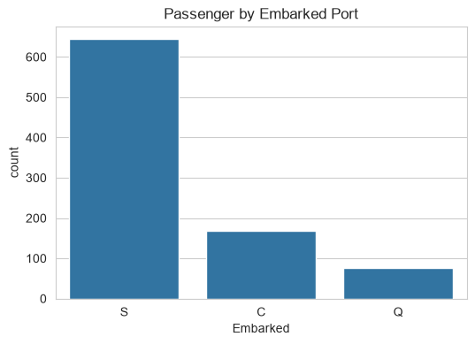
This count plot shows the number of passengers who boarded the Titanic at each of the three ports: Southampton (S), Cherbourg (C), and Queenstown (Q). The vast majority of passengers embarked at Southampton, followed by Cherbourg and then Queenstown. This helps understand the geographical origins of the passengers and may correlate with other features like ticket class.

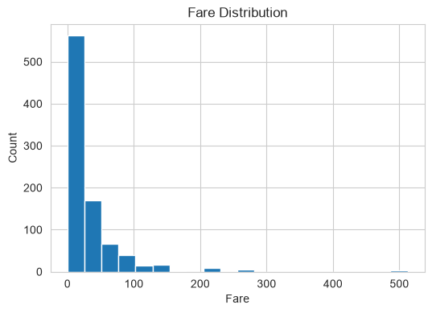
This histogram provides a detailed view of the ticket fare distribution across 20 bins. It reinforces the observation that the data is heavily right-skewed, with the vast majority of tickets costing less than 50 units. The long tail extending to the right shows the presence of very few, highly expensive tickets, indicating a huge disparity in passenger wealth.

5. Viva Questions
Q1. Why is data preprocessing important in machine learning?
Ans: Data preprocessing is essential because real-world data is often noisy, incomplete, and inconsistent. High-quality data leads to high-quality models. Preprocessing tasks like handling missing values, encoding categorical variables, and scaling features ensure that machine learning algorithms can interpret the data correctly and perform optimally.
Q2. What is the difference between Label Encoding and One-Hot Encoding?
Ans: Label Encoding assigns a unique integer to each category of a categorical variable (e.g., 0, 1, 2). This can introduce an unintended ordinal relationship (where algorithms assume 2 > 1). One-Hot Encoding, on the other hand, creates a new binary column for each category, indicating the presence (1) or absence (0) of that category, which prevents the algorithm from assuming any order.
Q3. Why did we apply StandardScaler to the 'Age' and 'Fare' columns?
Ans: 'Age' and 'Fare' have different scales and units. Algorithms that compute distances (like KNN) or use gradient descent are sensitive to feature scales, as larger scale features can dominate the model. StandardScaler standardizes these features to have a mean of 0 and a standard deviation of 1, ensuring they contribute equally to the model's learning process.
Q4. How did we handle missing values in the 'Age' column, and why choose that method?
Ans: We handled missing values in the 'Age' column by imputing them with the median age of the dataset. The median is often preferred over the mean for imputation because it is robust to outliers, ensuring that extreme values (like unusually old passengers) do not skew the imputed value.
Q5. What insights can be drawn from the 'Sex' vs 'Survived' count plot?
Ans: The plot strongly indicates that female passengers had a significantly higher survival rate compared to male passengers. This reflects the historical 'women and children first' evacuation policy on the Titanic, making passenger gender ('Sex') a highly influential feature for predicting survival.

